Mini-Project 1: Introduction to MATLAB Mobile

Lab Report

Name: Jiawei Zhu

Student ID Number: 923312684

Instructions
Download this lab report template and complete each section. Be sure to include this cover page along with your report. Upload your plots by copy-pasting them into this document. Submit a pdf of your completed lab report to Canvas by the deadline.

You may submit as many times as you wish up until the deadline. However, late submissions are not accepted. Questions begin on the following page and there is one question per page. When uploading your submission, do not change the order of questions or answer more than one question per page. Doing so may cause your submission to be imported incorrectly.

Note: it is a violation of academic integrity to submit code written by someone else or plots produced by someone else or by using another person’s code.

Question 1: Determining Phone Axes
Part A) This question refers to Step 3.1 in the lab manual. Upload the plots you used to determine the X, Y, Z axes of your phone. You should upload between 1 and 3 plots below. If you upload one plot, movement along each dimension (i.e. up/down, left/right, front/back) must be clearly visible.
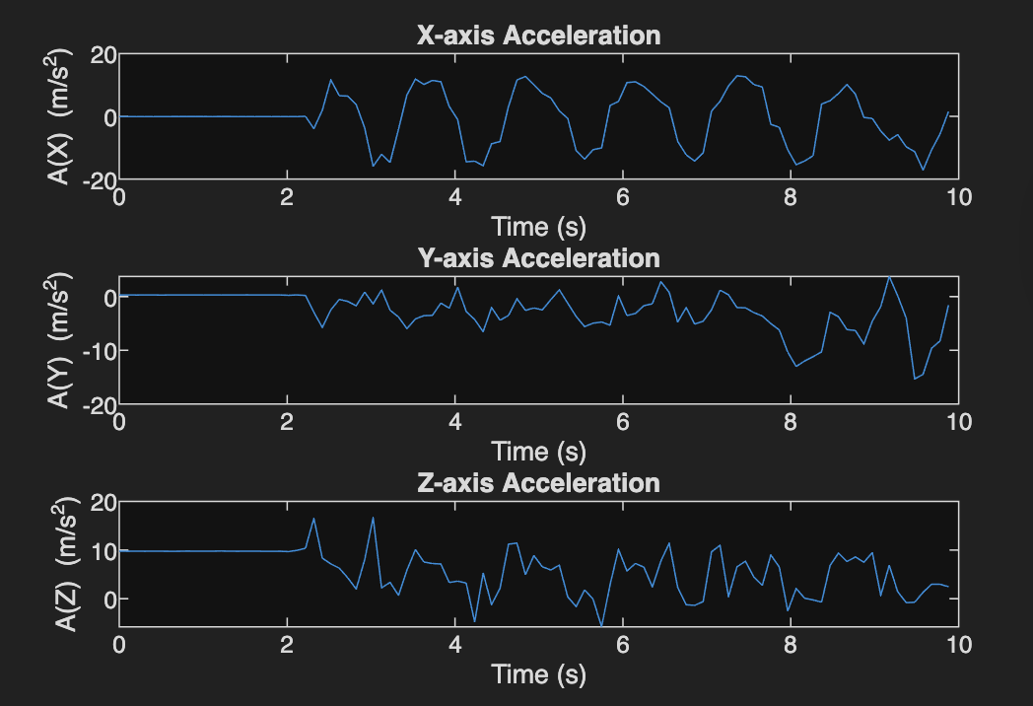

Well, this is the whole graph.

The first plot of the x-axis acceleration is “moving phone shift to the left and right”
Then, the second plot of the y-axis acceleration is “moving phone shift to the up and down
Finally, the third plot of the z-axis acceleration is “moving phone shift front and back.

Part B) This question refers to Step 3.1 in the lab manual. Upload your sketch (fine to take a picture with your phone) in which you label the X, Y, Z axes of your phone. An example is provided in Figure 7 in the lab manual.
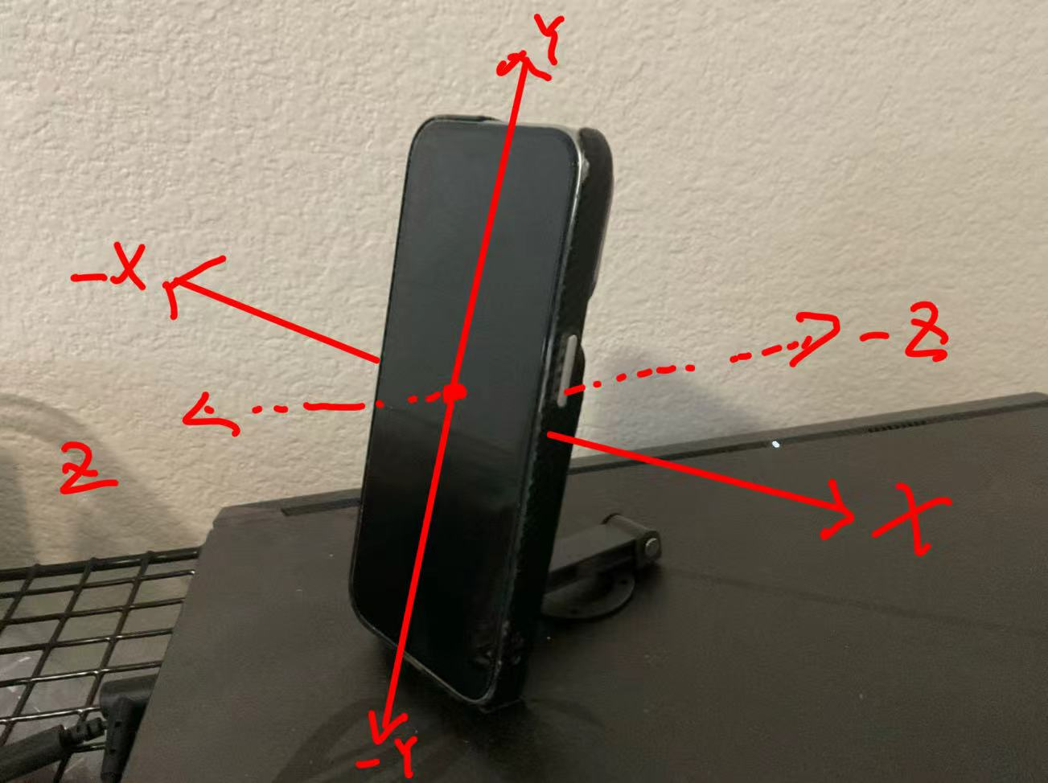

Question 2: Validation
Part A) This question refers to Step 3.2 in the lab manual. Include below, the plot you produced for Step 3.2.
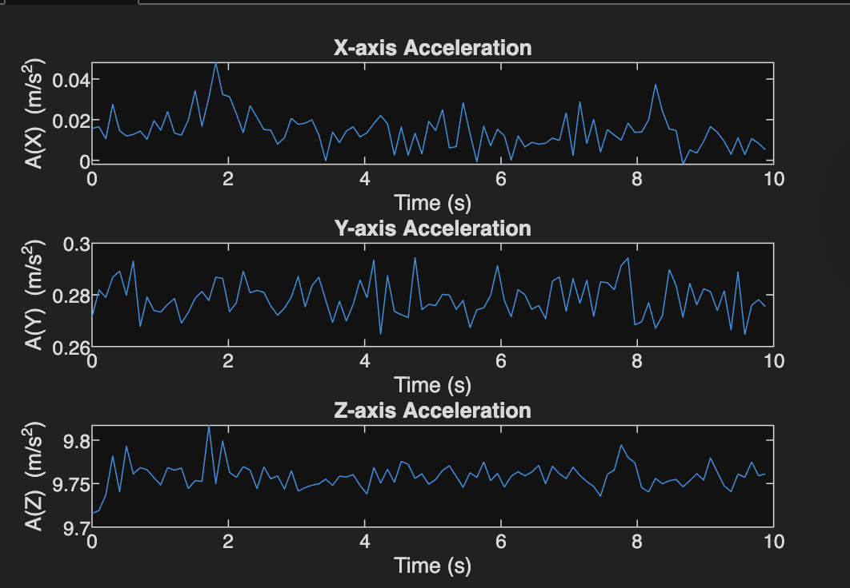

Part B) Write a short (1 paragraph max) reflection discussing the plot above. Does the plot make sense to you based on your physical intuition about acceleration? If so, why? If not, why not?
Well, these plots make sense about the acceleration for me. In Question 2 Part A, when the phone is fixed, the x-axis and y-axis are almost zero, the z-axis has a value of about 9.7-9.8 is normal because on the earth, everything needs to face gravity. And in Question 1 Part A, I moved my phone so all of them( X-axis, Y-axis, and Z-axis) have large number changes.

Question 3: AI Reflection
If you used AI for any aspect of your lab, you must complete a short reflection documenting your AI use. You must also attach a log (either as a text log, or screenshots) of your interaction with AI. Your log does not need to be exhaustive, but should provide a reasonable overview of your interaction with the AI: you should include the “important” questions you asked but can omit the complete text of the AI’s response and minor follow up questions. An example is provided on Canvas. Provide 1-3 sentences in answer to the following questions:

- Which AI tool(s) did you use? E.g. cursor, ChatGPT, Gemini, etc…

- Describe how you used AI in your lab. E.g. to help with debugging, to suggest ways to improve efficiency/clarity of your code, etc…

- What steps did you take to verify that the responses given to you by the AI were good ones?

Attach chat logs here

